**Virtualization of Operating Systems.**

After studying and tinkering with Oracle’s Virtual Box Software, 2 virtual machines, one of Debian Distribution and Windows 11 were successfully creating and ran without any hitches.

The Debian distribution machine ran Kali Linux Version 2022.2 on Rollin Updates.

The following was observed:

The virtual machines use the same CPU resource as the parent/host operating system as seen in the screenshot below which are also attached to a commit on GitHub:

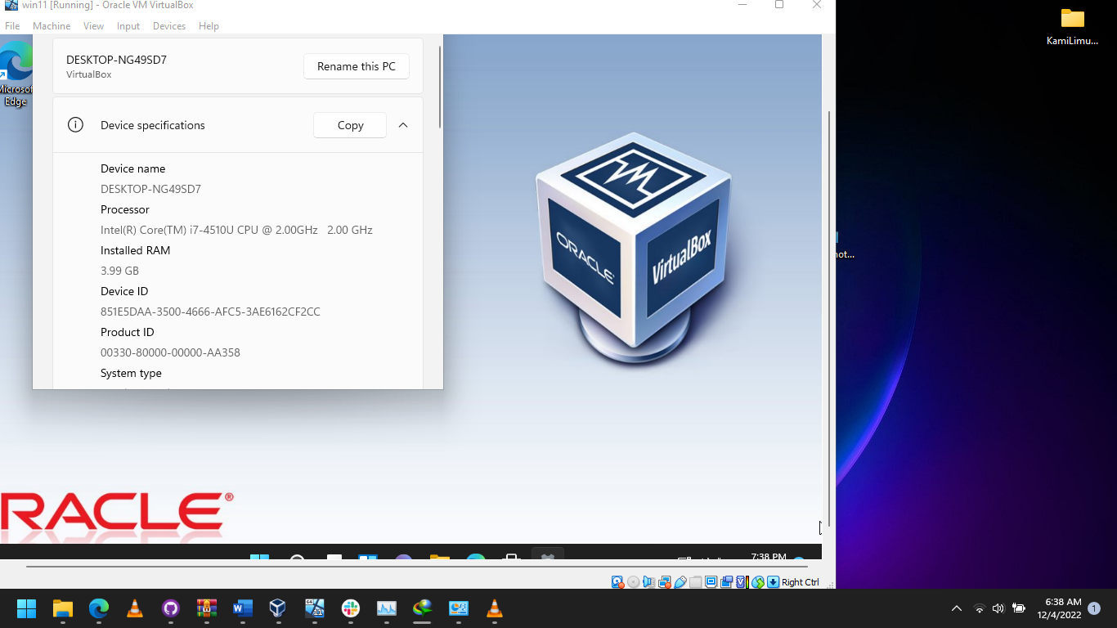

The above are screenshots from the virtual machine and the host operating system respectively. They show that the CPU name is the same as the host windows 11 operating system, meaning they share the same CPU.

The other resources such as RAM and hard disk capacity are determined by the user and can be changed at will.

For the Windows Virtual Machine, it was configured before installing the operating system, which included specifying the RAM capacity as well as the hard disk size.

Alternatively, a preconfigured Virtual Box image of the windows 11 machine can be downloaded and imported into Virtual Box then ran without any configuration.

The second alternative described above was used for the Kali Linux Machine.

A prebuilt Kali Linux Virtual Box Image was downloaded from the official Kali website ([Get Kali | Kali Linux](https://www.kali.org/get-kali/#kali-virtual-machines)). See screenshot below:

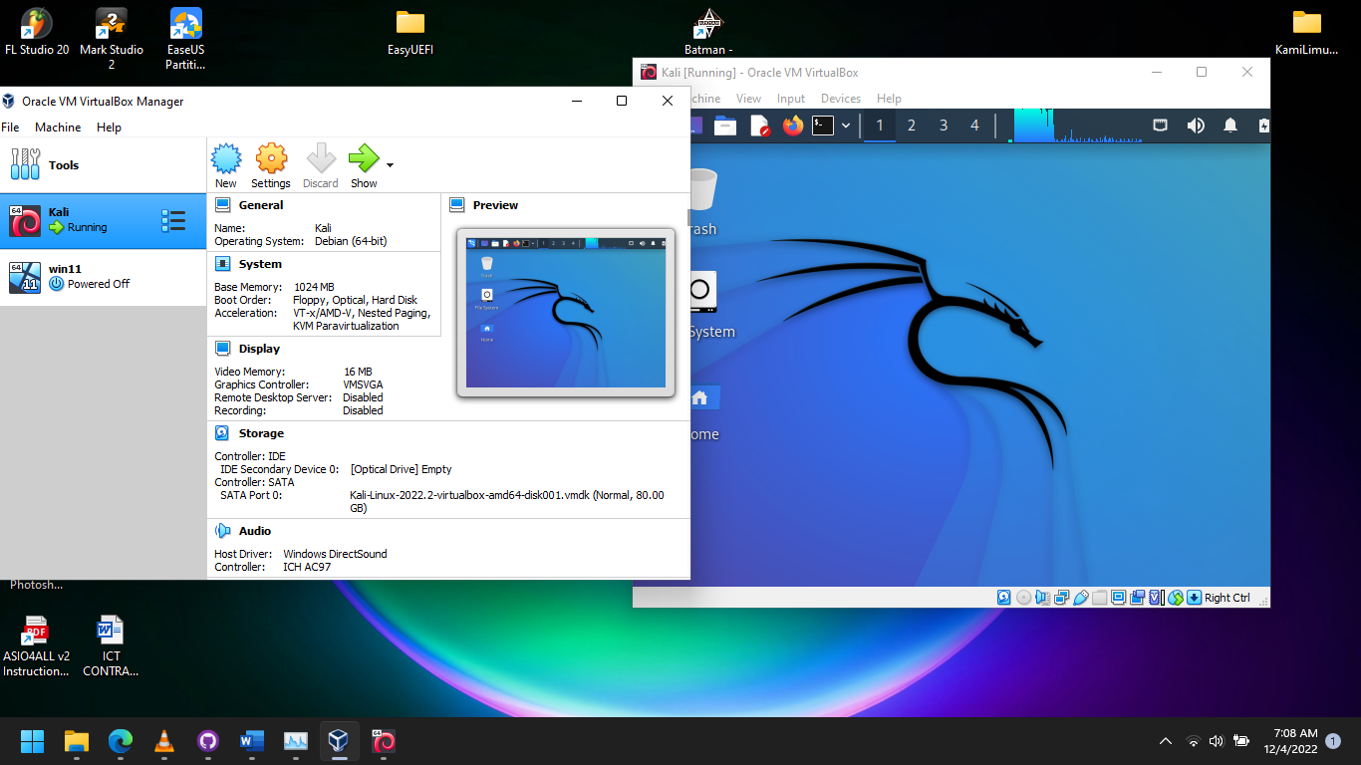

One is able to deal with the virtualized environment whatever is desired without running a risk of losing data when dealing with a real machine.

It is also good for testing malware without risk of having it leak to the host operating system.

Virtual box also offers the option to drag and drop files across the host and virtual operating system which is very convenient when dealing with files.